Step 1: Find receiver_id = bot_id and date > created date.

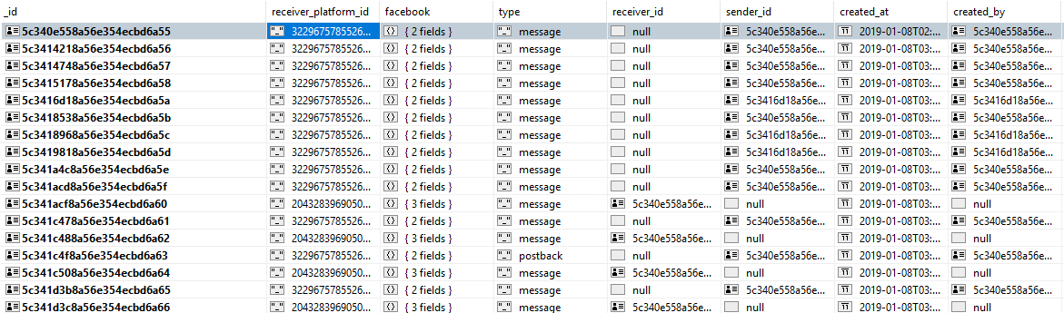

Step 2: Group by sender_id and push all the message into an array

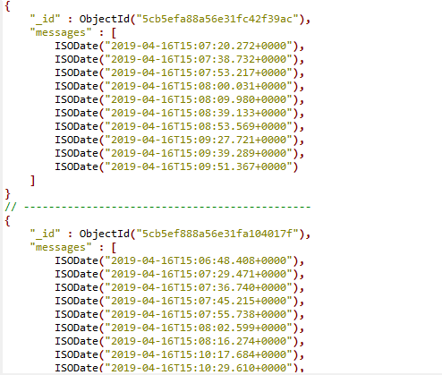

Step 3: Pack the arrays with index (to prepare for next step to get time difference)

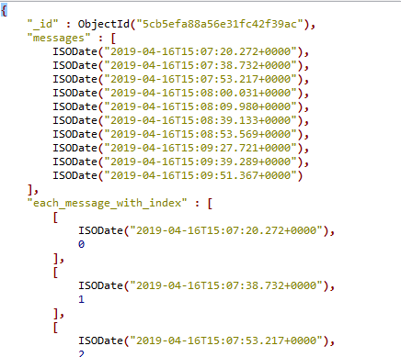

Step 4: pack the arrays into pair, index 0 with index 1 and so on, still group by user_id

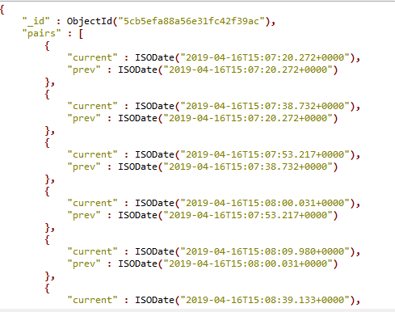

Step 5: unwind each of the array pairs into each element. The sender_id will break off now as shown.

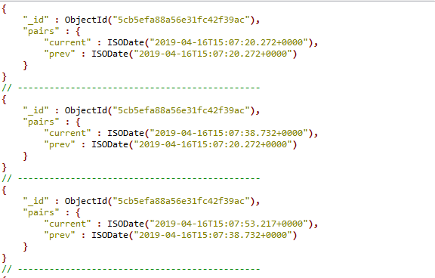

Step 6: add fields for date month year already considered GMT+8 time, you can use time zone difference or tzlist timezone based on whichever you want.

<https://en.wikipedia.org/wiki/List_of_tz_database_time_zones>

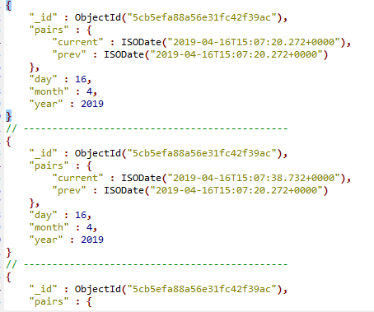

Step 7: add a field to get the time difference between the pairs

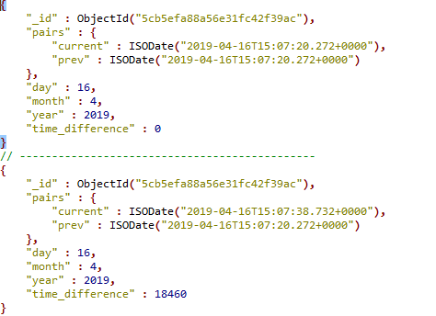

Step 8: count the fields with time difference of more than 3 minutes. At the end, the users are grouped together and the count is +1 for each user as the first conversation of the user with the bot is not considered yet.

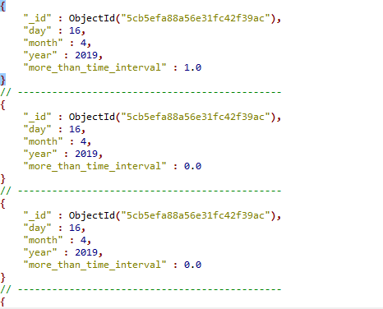

Step 9: Group the conversation by day month and year then do an aggregate count.

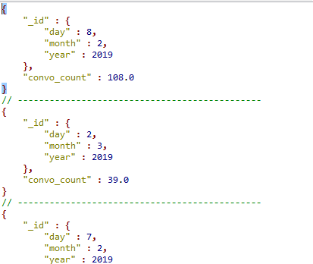

Step 10: Sort by day, month year

